BIG DATA-HADOOP
- Map reduce – Data processing + resource management
- HDFS – (Hadoop distubuted file system) – Data storage
- Yarn – (yet another resource negotiator):resource manager

Hadoop 1.x
- Map reduce – Data processing + resource management
- HDFS – (Hadoop distubuted file system) – Data storage
Hadoop 2.x:
- Map reduce – Data processing + resource management
- HDFS – (Hadoop distubuted file system) – Data storage
- Yarn – (yet another resource negotiator):resource manager
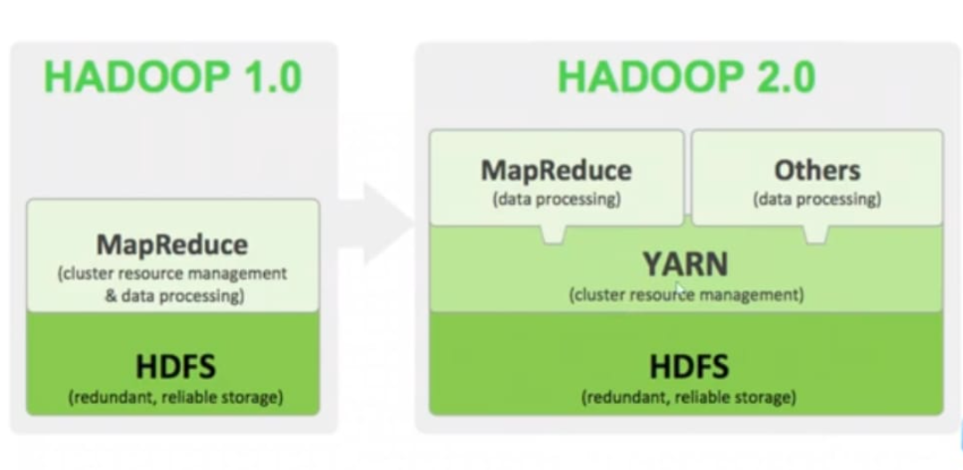

- Hadoop supported files:
- Json
- Csv
- Txt
- Xml
- Parquet
- Orc
- Sequence file
- Photos
- Pdf’s
- Table
- Database
- Social media

- Features of Hadoop:
- Reliable: handle failure. (Data replication)
- Flexible: add more systems without down time
- Economical: Commercial H/W used in cheap
- Stable: reliable + consistency of the system, it will work without any expected error/failures

- HDFS:
- It is designed to store and manage large datasets/files across clusters.
- It is core component of the Hadoop eco system.
- It is a responsible for providing reliable and fault tolerance storage for big data applications.

Components:
- Name node: Name node stores only metadata information
- E.g. : actual metadata size 10 MB
- Metadata: data about data
    - File_name : image
    - File_type: JPG
    - File size: 10mb
    - Storage_location: pictures/images.jpg
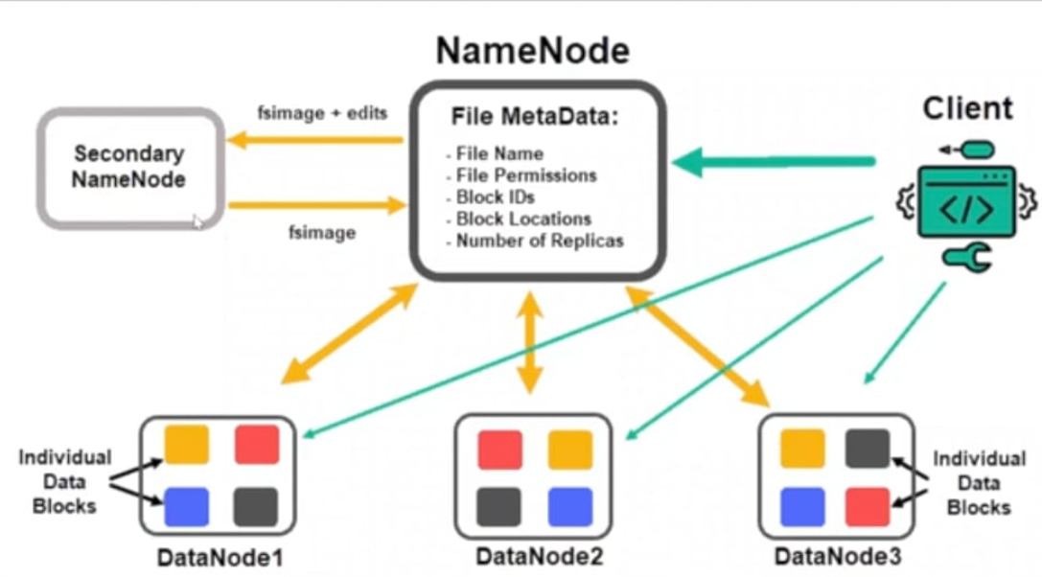

- Data node: data node stores actual data
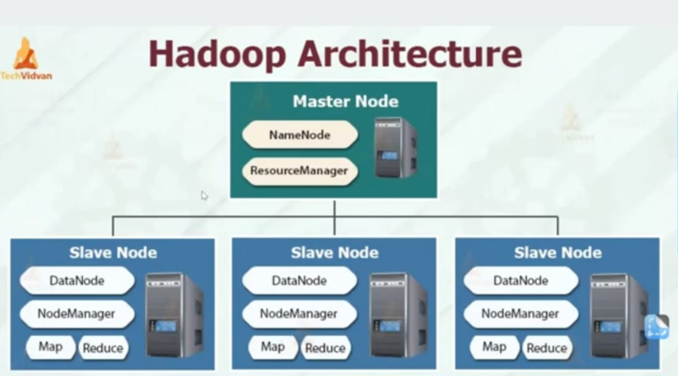

20-12-2024
- Blocks: any kind of data is stored in block wise in HDFS.(HDFS-site.xml)
- Hard disk:4 kb
- HDFS: 128 mb
- Image.jpg : 10mb

- Replication:
- Property in configuration file :3. It is possible to increase or decrease.(HDFS-site.xml)

- Heart beats:
- Data node sends heartbeats to name node every 3 seconds. Then name node knows that data nodes are available.

- We can connect HDFS storage two ways:

- 1.using cli hdfs commands

- 2.web browser

- HDFS commands:

- Ls – ltr

- Hdfs dfs -ls /

- Hdfs dfs -ls / user/

- Hdfs dfs -ls / user/cloudera/ -----------------------------------ls command (no files in cloudera)

- Hdfs dfs -chmod 777 /user/cloudera/honey----------------chmod 777 honey

- Folder creation in hdfs:

- Hdfs dfs -mkdir/user/cloudera/honey-----------------------mkdir honey(create folder)

- Hdfs dfs -rm -r /user/cloudera/honey---------------------------------rm-r honey

- Copy: cp linux_source_location linux_target_location

- Hdfs dfs -put local_file_system(lfs) Hadoop_distrubuted_file_system(hdfs)

- Hdfs dfs -copyfromlocal local_file_system(lfs) Hadoop_distrubuted_file_system(hdfs)

- Hdfs dfs -put file_name.txt /user/cloudera

- Hdfs dfs -get local_file_system(lfs) Hadoop_distrubuted_file_system(hdfs)

- Hdfs dfs -get /user/cloudera/ file_name.txt

- Cat file_name.txt
- Clear

- Hdfs dfs -CP /user/cloudera/ file_name.txt /user/----------------------copy file command

- Hdfs dfs -mv /user/ file_name.txt /user/hdfs/-----------------------------move file command

- Hdfs dfs -rm /user/ file_name.txt /user/hdfs/-----------------------------remove file command

- Hdfs dfs -cat /user/cloudera/ file_name.txt---------------------------create file command

- Hdfs dfs -chgrp Hadoop /user/cloudera/ file_name.txt

